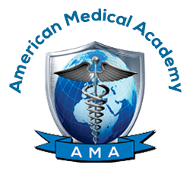
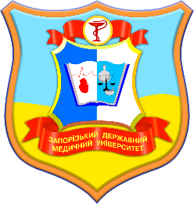

AMA-ZSMU MEDICAL

CAMPUS IN POLAND

Initial Application – MD Program

Name: Date of Birth:

Last First Middle dd/mm/year

Sex: □Male □Female Marital Status: □Single □Married

Citizenship: Place of Birth:
City/Country

Passport#: Date Issued: Place Issued:

Home Address:

Street Box/Apt.# City Country Zip Code

( ) ( )

Telephone Number Mobile Number Email Address

Mailing Address (if different):
Street Box/Apt.# City  ( ) |  | Country | Zip Code
Telephone Number | Email Address
Emergency Contact Information:
Name:
Last | First |  | Middle

Relationship to applicant:

Address:
Street Box/Apt. #  ( ) | City  @ | Country | Zip Code
Telephone Number | Email Address
Educational Background: (if additional room is needed, please attach a separate sheet)
You must attach an official copy of transcripts from all schools attended as well as your school leaving diploma or certificate

Please list all secondary schools you have attended:
Name of Institution | Years Attended | Date of Graduation | Diploma Number | Date Diploma Issued | Type of  Degree/Diploma Received

Please list all colleges and/or universities you have attended:
Name of Institution | Years Attended | Degree/Diploma Received

Please list all languages you speak and your level of knowledge:
Language | Degree of Knowledge (Beginner, Intermediate, Advanced)

General Information

All applicants are required to provide a short CV, a copy of their passport, a copy of his/her academic transcripts, and why he/she wants to study Medicine (a short one-paragraph essay), for admission consideration.

I certify that I have completed this application myself and without assistance; the information given in this application is complete and accurate.

I understand that the American Medical Academy Inc., and AMA Poland z.o.o. reserves the right to verify all the information listed in the application. I understand that giving false or misleading information in the application will result in exclusion from the completion of the program.

Signature of Applicant Date

